
COMSATS UNIVERSITY ISLAMABAD
ATTOCK CAMPUS

Submitted by:
Shahwaiz Ahmed (FA25-BCS-039)

BCS (3rd Semester)

Submitted to:

Mr. Bilal Bukhari

Course:
Data Structure Lab

ASSIGNMENT NO: 01

Submission date: 18 Sep 2026

Lab Assignment 1
Array List, pointer, Traversal and Problem solving

Code:
#include <iostream>
#include <cmath>
using namespace std;
const int CAPACITY = 20;
struct ArrayList
{
int data[CAPACITY];
int size = 0;
};
bool insertEnd(ArrayList &list, int value)
{
if (list.size >= CAPACITY)
{
return false;
}
list.data[list.size] = value;
list.size++;
return true;
}
bool insertAtBeginning(ArrayList &list, int value)
{
if (list.size >= CAPACITY)
{
return false;
}
for (int i = list.size; i > 0; i--)
{
list.data[i] = list.data[i - 1];
}
list.data[0] = value;
list.size++;
return true;
}
bool deleteAtPosition(ArrayList &list, int position)
{
if (position < 0 || position >= list.size)
{
return false;
}
for (int i = position; i < list.size - 1; i++)
{
list.data[i] = list.data[i + 1];
}
list.size--;
return true;
}
void displayList(const ArrayList &list)
{
for (int i = 0; i < list.size; i++)
{
cout << list.data[i];
if (i < list.size - 1)
{
cout << " ";
}
}
cout << endl;
}
int main()
{
ArrayList list;
int regNoLastTwoDigits = 8;
insertEnd(list, 18);
insertEnd(list, 7);
insertEnd(list, 45);
insertEnd(list, 11);
insertEnd(list, 36);
insertEnd(list, regNoLastTwoDigits);
insertEnd(list, 21);
insertEnd(list, 13);
insertEnd(list, 29);
cout << "Initial ArrayList: ";
displayList(list);
int *ptr = list.data;
int *minPtr = list.data;
int *maxPtr = list.data;
int *medianPtr = list.data;
int *closestPtr = list.data;
int sum = 0;
for (int i = 0; i < list.size; i++)
{
sum += *ptr;
if (*ptr < *minPtr)
{
minPtr = ptr;
}
if (*ptr > *maxPtr)
{
maxPtr = ptr;
}
ptr++;
}
cout << "Minimum Value: " << *minPtr << endl;
cout << "Maximum Value: " << *maxPtr << endl;
int temp[CAPACITY];
for (int i = 0; i < list.size; i++)
{
temp[i] = list.data[i];
}
for (int i = 0; i < list.size - 1; i++)
{
for (int j = 0; j < list.size - i - 1; j++)
{
if (temp[j] > temp[j + 1])
{
int t = temp[j];
temp[j] = temp[j + 1];
temp[j + 1] = t;
}
}
}
int medianValue = temp[list.size / 2];
for (int i = 0; i < list.size; i++)
{
if (list.data[i] == medianValue)
{
medianPtr = list.data + i;
break;
} }
cout << "Median Value: " << *medianPtr << endl;
cout << "Sum: " << sum << endl;
double generalAverage = (double)sum / list.size;
double specialAverage = (*minPtr + *medianPtr + *maxPtr) / 3.0;
ptr = list.data;
closestPtr = list.data;
double minDiff = fabs(*ptr - specialAverage);
for (int i = 0; i < list.size; i++)
{
double currentDiff = fabs(*ptr - specialAverage);
if (currentDiff < minDiff)
{
minDiff = currentDiff;
closestPtr = ptr;
}
ptr++;
}
int closestPosition = closestPtr - list.data;
cout << "General Average: " << generalAverage << endl;
cout << "Special Average: " << specialAverage << endl;
cout << "Closest Value: " << *closestPtr << endl;
cout << "Position of Closest Value: " << closestPosition << endl;
double averageDifference = fabs(generalAverage - specialAverage);
double finalScore = fabs(*closestPtr - generalAverage) + fabs(*closestPtr - specialAverage) + averageDifference;
cout << "Difference Between Averages: " << averageDifference << endl;
cout << "Final Score: " << finalScore << endl;
deleteAtPosition(list, closestPosition);
cout << "ArrayList After Deletion: ";
displayList(list);
int roundedSpecialAvg = round(specialAverage);
insertAtBeginning(list, roundedSpecialAvg);
cout << "Final ArrayList After Insertion: ";
displayList(list);
return 0;
}
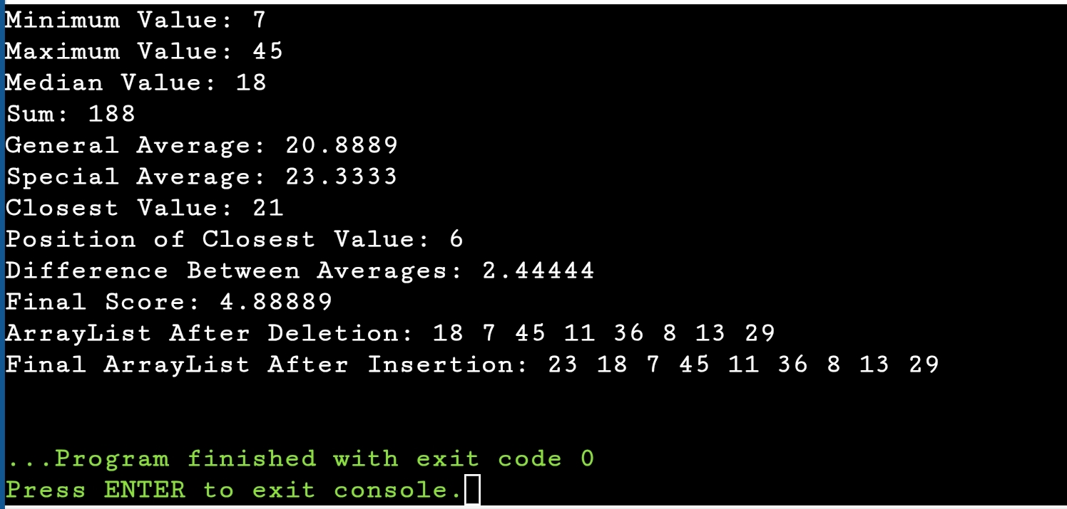
OUTPUT:

